- Design an HTML page with the relevant CSS (inline /internal/external styles) for the following use case:

b. Menu page for a restaurant (expected to use list, image, and other text formatting
tags)

SOURCE CODE

<html>
<head>
<title>The Olive & Thyme | Menu</title>

<style>
body {
background-color: #f5ebdd;
margin: 0;
font-family: Arial, sans-serif;
color: #34483c;
}

.header {
background-color: #34483c;
color: #f5ebdd;
text-align: center;
padding: 25px;
}

.header h1 {
font-family: "Trebuchet MS", "Lucida Sans Unicode", "Lucida Grande",
"Lucida Sans", Arial, sans-serif, serif;
font-size: 40px;
letter-spacing: 3px;
}

.header p {
color: #d9c9a9;
font-style: italic;
font-family: "Trebuchet MS";
}

.navbar {
background-color: #78816a;
padding: 15px;
text-align: center;
}

.navbar a {
color: white;
text-decoration: none;
margin: 20px;
font-size: 17px;
}

.navbar a:hover {
color: #f5ebdd;
}

.welcome {
text-align: center;
padding: 40px;
}

.welcome h2 {
font-family: Georgia, serif;
font-size: 32px;
}

.welcome p {
font-size: 18px;
line-height: 2;
}

.welcome img {
width: 550px;
max-width: 90%;
height: 270px;
object-fit: cover;
border-radius: 12px;
}

.menu {
background-color: #e5d9c8;
padding: 40px 10%;
}

.menu-heading {
font-family: Georgia, serif;
color: #a45f43;
font-size: 30px;
border-bottom: 2px solid #a45f43;
padding-bottom: 10px;
}

.food-item {
padding: 12px;
margin-bottom: 12px;
border-bottom: 1px dotted #a45f43;
}

.food-row {
display: flex;
justify-content: space-between;
align-items: center;
}

.food-name {
font-size: 20px;
font-weight: bold;
margin-bottom: 5px;
}

.food-description {
font-size: 15px;
color: #69715e;
font-style: italic;
}

.price {
color: #a45f43;
font-size: 18px;
font-weight: bold;
}

.gallery {
text-align: center;
padding: 40px;
}

.gallery img {
width: 220px;
height: 170px;
object-fit: cover;
border-radius: 10px;
margin: 12px;
transition: 0.3s;
}

.gallery img:hover {
transform: scale(1.05);
}

.bestsellers {
background-color: #34483c;
color: #f5ebda;
padding: 35px 10%;
}

.bestsellers h2 {
font-family: "Palatino Linotype", serif;
color: #f5ebda;
font-size: 32px;
text-align: center;
}

.bestsellers p {
color: #d8c49c;
text-align: center;
font-style: italic;
}

.bestsellers ol {
padding-left: 30px;
}

.bestsellers li {
background-color: #f5ebda;
color: #34483c;
padding: 15px;
margin: 12px;
border-left: 5px solid #c49a45;
font-size: 18px;
border-radius: 5px;
}

.bestsellers li b {
color: #34483c;
}

.special {
background-color: #78816a;
color: white;
text-align: center;
padding: 40px;
}

.special h2 {
font-family: Georgia, serif;
font-size: 30px;
}

.contact {
background-color: #34483c;
color: #f5ebdd;
text-align: center;
padding: 35px;
}

.contact h2 {
font-family: Georgia, serif;
}

.contact p {
line-height: 1.8;
}
</style>
</head>

<body>
<div class="header">
<h1>THE OLIVE & THYME</h1>
<p>Where every meal feels special.</p>
</div>

<div class="navbar">
<a href="#home">Home</a>
<a href="#menu">Menu</a>
<a href="#special">Specials</a>
<a href="#contact">Contact</a>
</div>

<div class="welcome" id="home">
<h2>| A Taste of Something Special |</h2>

<p>
Welcome to The Olive & Thyme! We believe that good food brings people
together.
<br />
Explore our carefully prepared dishes, made with fresh ingredients and a
whole lot of love.
</p>

<img src="istockphoto-1352856480-612x612.jpg" />
</div>

<div class="menu" id="menu">
<h2 class="menu-heading">01 — Starters</h2>

<div class="food-item">
<div class="food-row">
<p class="food-name">Classic Bruschetta</p>
<p class="price">₹180</p>
</div>

<p class="food-description">
Toasted bread topped with fresh tomatoes, basil and olive oil.
</p>
</div>

<div class="food-item">
<div class="food-row">
<p class="food-name">Creamy Mushroom Soup</p>
<p class="price">₹160</p>
</div>
<p class="food-description">
Slow-cooked mushrooms blended into a rich and creamy soup.
</p>
</div>

<div class="food-item">
<div class="food-row">
<p class="food-name">Golden Garlic Bread</p>
<p class="price">₹140</p>
</div>
<p class="food-description">
Freshly baked bread with garlic butter and Italian herbs.
</p>
</div>

<div class="food-item">
<div class="food-row">
<p class="food-name">Crispy Potato Wedges</p>
<p class="price">₹190</p>
</div>
<p class="food-description">
Seasoned potato wedges served with our special dipping sauce.
</p>
</div>

<h2 class="menu-heading">02 — Main Course</h2>

<div class="food-item">
<div class="food-row">
<p class="food-name">Creamy Alfredo Pasta</p>
<p class="price">₹140</p>
</div>

<p class="food-description">
Penne pasta tossed in a creamy parmesan sauce with fresh herbs.
</p>
</div>

<div class="food-item">
<div class="food-row">
<p class="food-name">Margherita Pizza</p>
<p class="price">₹280</p>
</div>
<p class="food-description">
Classic tomato sauce, mozzarella cheese and fresh basil.
</p>
</div>

<div class="food-item">
<div class="food-row">
<p class="food-name">Garden Vegetable Lasagna</p>
<p class="price">₹280</p>
</div>
<p class="food-description">
Layers of pasta, roasted vegetables and melted cheese.
</p>
</div>

<div class="food-item">
<div class="food-row">
<p class="food-name">Grilled Sandwich</p>
<p class="price">₹220</p>
</div>
<p class="food-description">
A toasted sandwich filled with vegetables, cheese and house seasoning.
</p>
</div>

<h2 class="menu-heading">03 — Desserts</h2>

<div class="food-item">
<div class="food-row">
<p class="food-name">Chocolate Brownie</p>
<p class="price">₹180</p>
</div>
<p class="food-description">
Warm chocolate brownie served with vanilla ice cream.
</p>
</div>

<div class="food-item">
<div class="food-row">
<p class="food-name">Classic Tiramisu</p>
<p class="price">₹220</p>
</div>
<p class="food-description">
Coffee-soaked sponge layered with creamy mascarpone.
</p>
</div>

<h2 class="menu-heading">04 — Beverages</h2>

<div class="food-item">
<div class="food-row">
<p class="food-name">Iced Cold Coffee</p>
<p class="price">₹140</p>
</div>
<p class="food-description">
Chilled coffee blended with milk and a touch of sweetness.
</p>
</div>

<div class="food-item">
<div class="food-row">
<p class="food-name">Italian Lemonade</p>
<p class="price">₹150</p>
</div>
<p class="food-description">
Fresh lemon juice blended with sparkling water and a hint of
sweetness.
</p>
</div>
</div>

<div class="gallery">
<h2 class="menu-heading">Fresh From Our Kitchen</h2>

<img src="DSC_0362.webp" alt="Pasta" />
<img src="images (1).jpg" alt="Pizza" />
<img src="images (2).jpg" alt="Dessert" />
</div>

<div class="bestsellers">
<h2>Our Most Loved Dishes</h2>

<p>Customer favourites, made with love!</p>

<ol>
<li>
<b>Margherita Pizza</b> – Our classic bestseller, topped with fresh
basil and mozzarella.
</li>

<li><b>Creamy Alfredo Pasta</b> – Rich, creamy and full of flavour.</li>

<li>
<b>Chocolate Brownie</b> – A warm chocolate treat with vanilla ice
cream.
</li>
</ol>
</div>

<div class="special" id="special">
<h2>THE CHEF'S SPECIAL</h2>

<h3>Italian Feast Combo</h3>

<p>Enjoy a pizza, a pasta and a dessert of your choice!</p>

<h2>₹599</h2>

<p><i>Available for a limited time.</i></p>
</div>

<div class="contact" id="contact">
<h2>Come Dine With Us!</h2>

<p>
12 Garden Road, Bengaluru
<br />
Contact: 9876543210
<br />
Opening Hours: 11 AM - 10 PM
</p>

<p>
<b>Follow us for updates and special offers!</b>
</p>

<p>
<u>Instagram</u> |
<u>Facebook</u>
</p>

<i style="font-family: Trebuchet MS">Good food brings people together.</i>
</div>
</body>
</html>

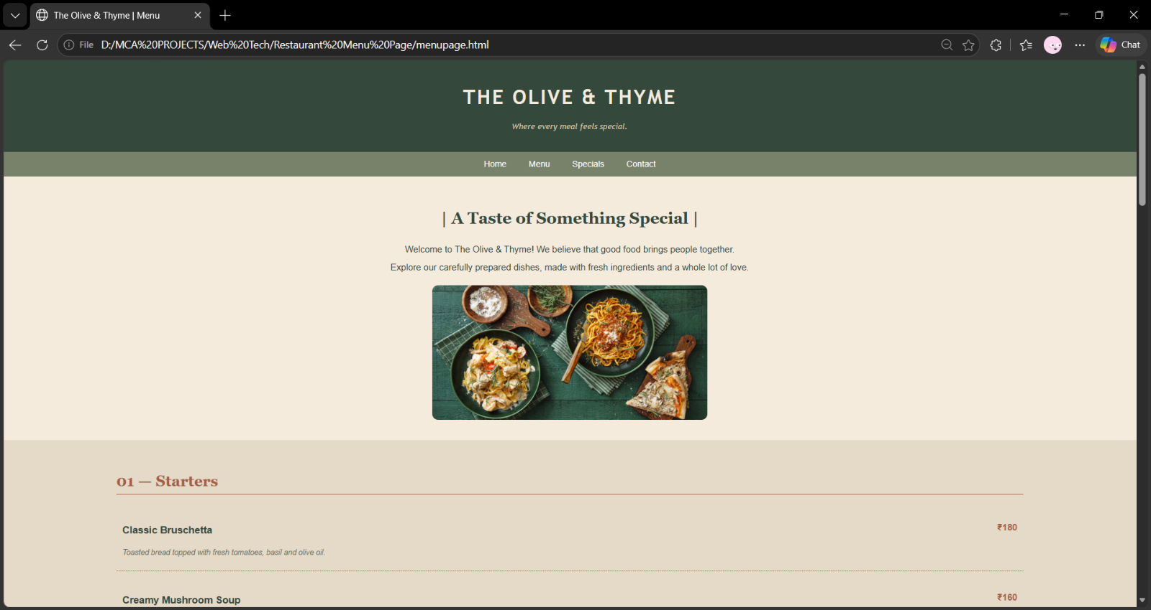
OUTPUT



